**Ed’s Robot Project - Week 2**

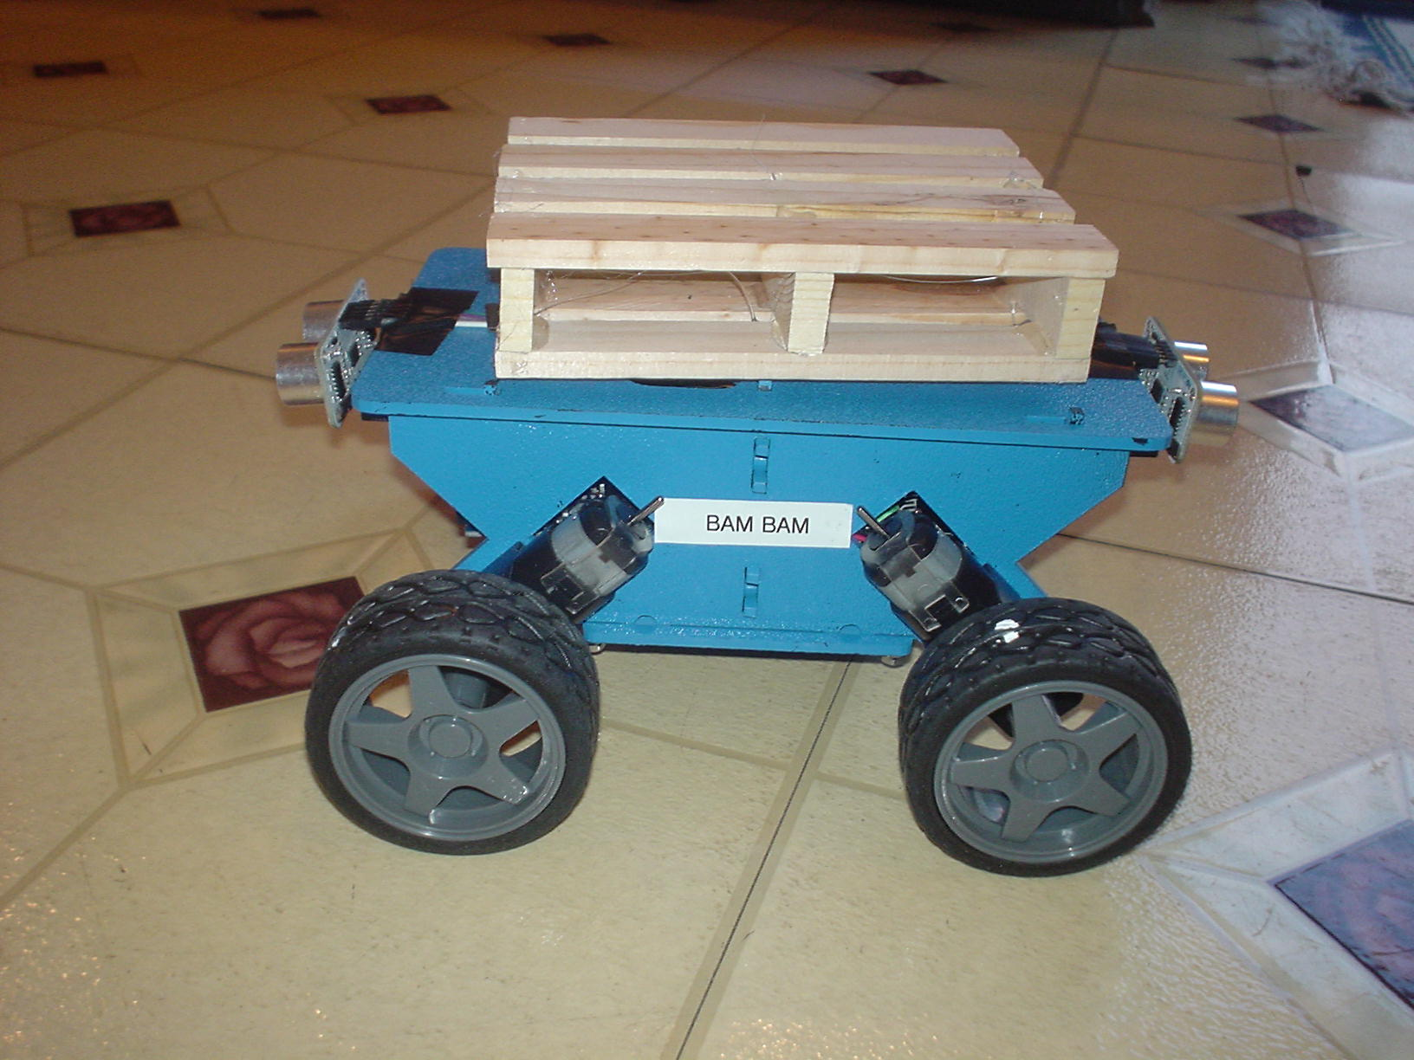

I thought I was kidding about painting it and building shipping palettes.

But I’m still waiting for parts to come in.

I picked up a small wooden box in the craft section at WalMart for $5 and built my palettes!

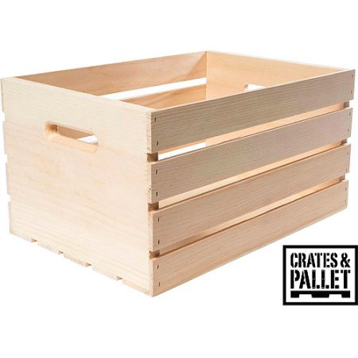 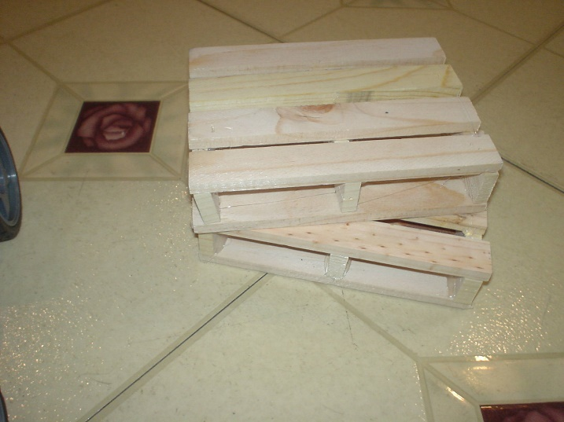

And some paint from Ace Hardware :



**Finished Power Compartment**

I moved the components to the inside of the chassis:

Inserted the battery with access to charging connector, mounted the power switch with diode for reverse polarity protection (on right) and the motor controller is also inside.

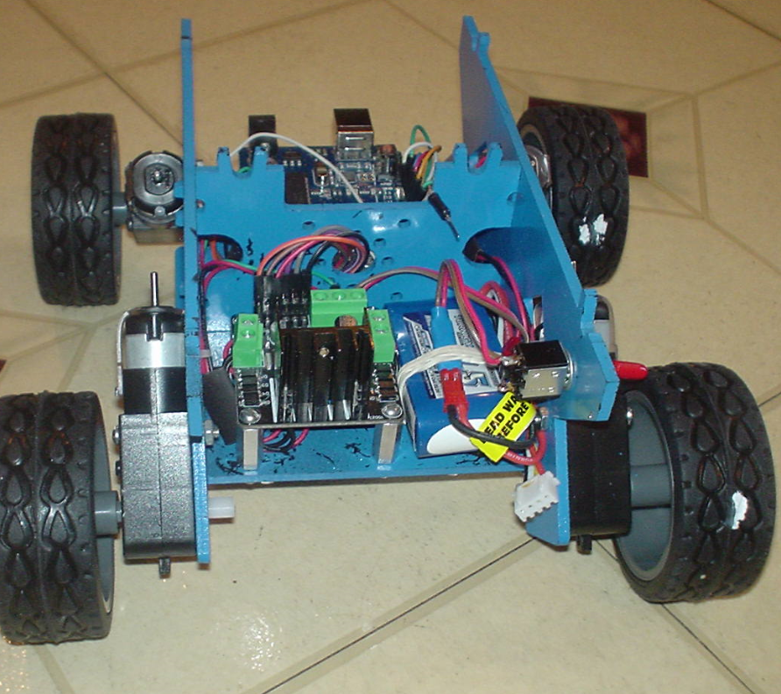

**Arduino Compartment**

The Arduino is mounted inside too with the programming port accessible and the motor wiring cleaned up.

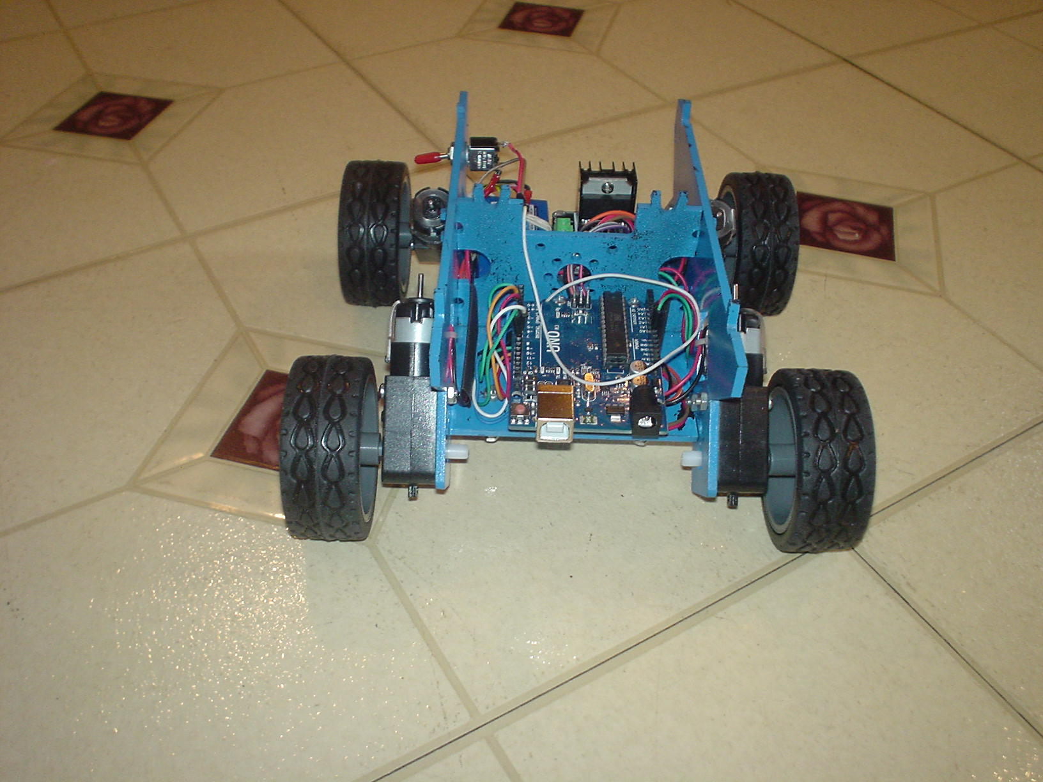

**Top Panel**

Here’s the top with the right and left switches and ultrasonic sensor wiring.

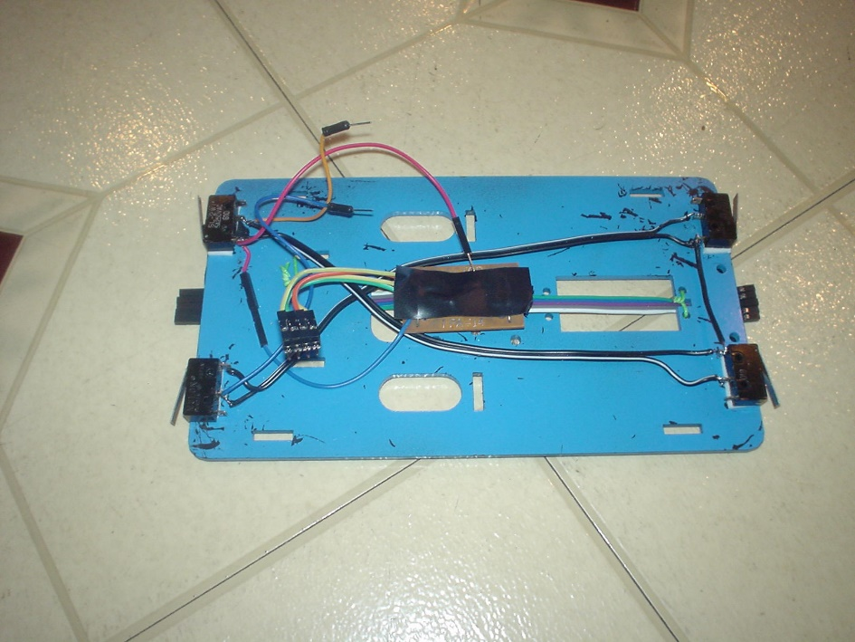

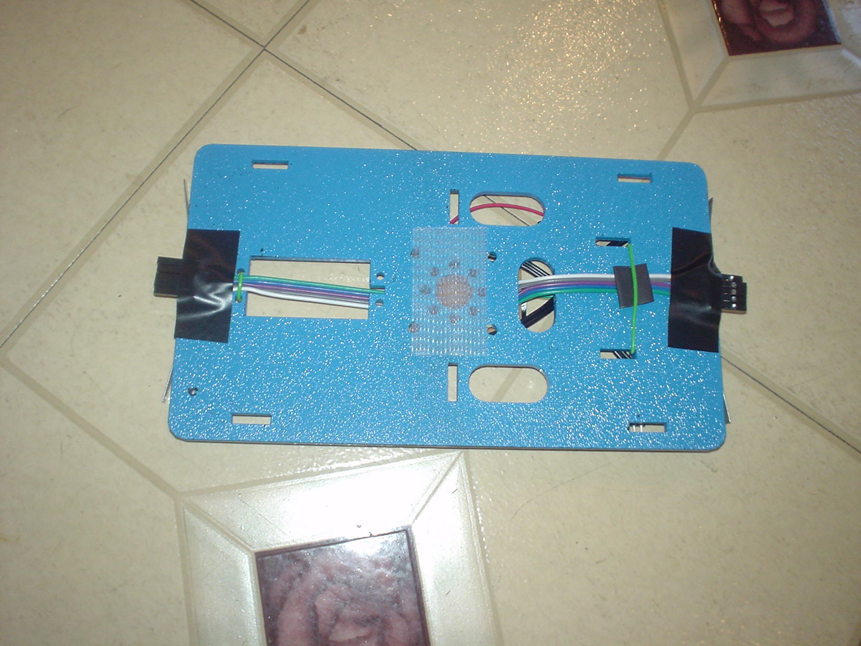

Attaching the top

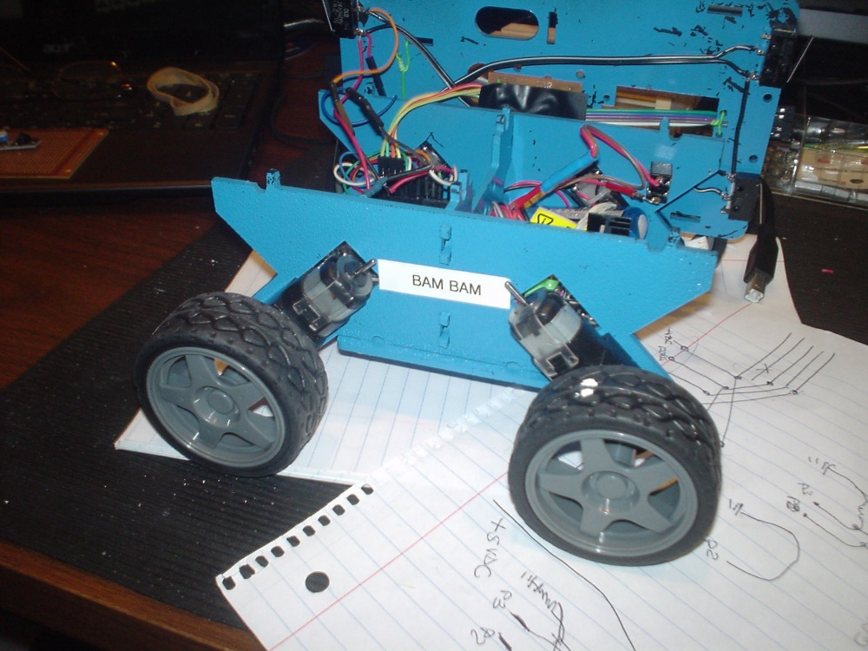

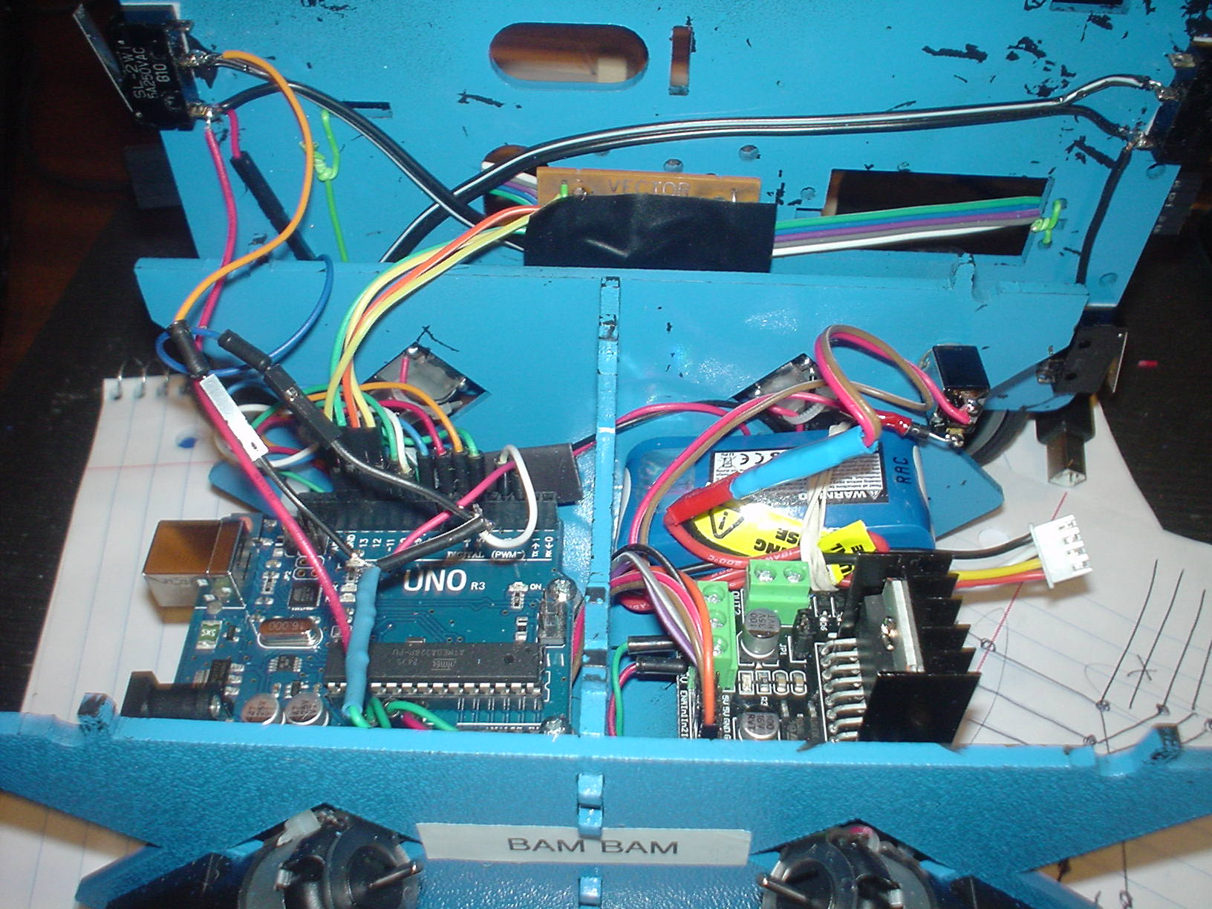

Tweaking the Code

Testing collision avoidance code at the test track…

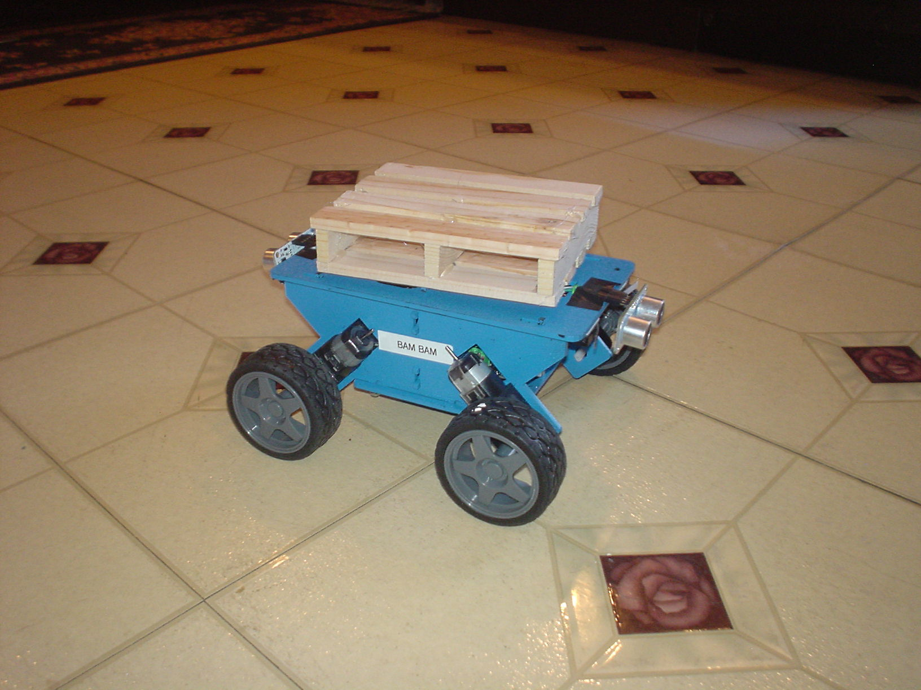

The line sensors are next – will I be able to find enough spare pins?